**REST & RECUPERATE**

Relax at Elk Creek Resort while vacationing in the Black Hills of South Dakota. Take in the splendor of the valley from the porch of our country cottages or vacation home. Soak up the sun by the heated pool. Our camp-ground has RV hookups, tent sites, motel rooms, kitchenette rooms, log cabins, a 2-level house, sleeping cabins, shower house, laundry facilities, an outdoor chapel for weddings, a recreational lodge for receptions or events and a convenience store. Also featured at the resort is the Petrified Forest and Museum with its Pine Tree Gift Shop and Gallery of Stone Rock Shop.

Elk Creek Resort is centrally located to most major tourist attractions such as:

* Petrified Forest
* Mt. Rushmore
* Historic Deadwood
* Motorcycle Museum
* Bear Country
* Reptile Gardens
* Custer State Park
* Spearfish Canyon

We are located 1 mile east of the Interstate-90, exit 46, between Rapid City and Sturgis.

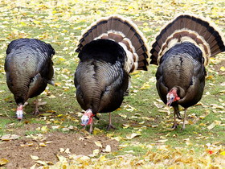

If you are looking for somewhere to relax & unwind, this is the place. Turkeys & deer wander through the grounds in the mornings & evenings.

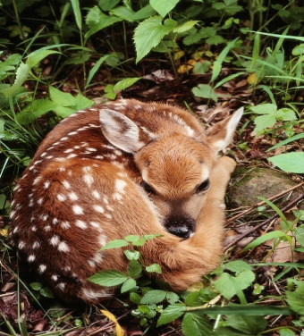

ELK CREEK RESORT Winter 2023-2024

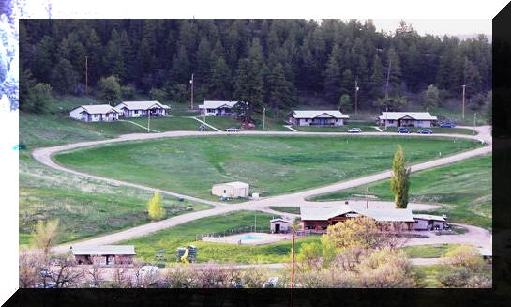

**8220 Elk Creek Road**

**Piedmont, SD 57769**

**www.elkcreekresort.net**

**Email: info@elkcreekresort.net**

**605-787-4884**

|  |  |  |
| --- | --- | --- |
| **3 & 4-PLEX COTTAGE UNITS** | | |
| Beautiful view overlooking the resort. Each room has a full bath & is furnished with a TV, A/C, heater, small refrigerator, microwave, coffee pot & an entry porch. The kitchen rooms also include a range, refrigerator, sink, kitchen utensils, toaster & a dining table. *There will be a* *$10.00 fee per person over the stated capacity. Rates will vary based on reservation dates.* | | |
| **Standard Room** | Sleeps 4 People | Starting at $129.95 |
| **Standard Room w/kitchenette** | Sleeps 5 People | Starting at $149.95 if available |
| **Deluxe Room w/kitchenette** | Sleeps 8 People | Starting at $189.95 if available |

|  |  |  |
| --- | --- | --- |
| **FURNISHED DRY CABINS** | Each cabin has an entry porch. One queen bed, 2 double sleepers w/ twins overhead. Includes A/C-heater, sm. refrigerator, table, chairs, all bedding (no towels), & picnic table. Guests use nearby shower house and restroom. Sleeps 8 | Starting at $110.00 if available |

|  |  |
| --- | --- |
| **RVs / Camping** | |
| Electric (30/50 amp), Water, Sewer. | $ 54 and up |
| Electric (30/50 amp), Water | $ 48 and up |
| Electric (30/50 amp) | $ 39 and up |
| No Hook-ups | $ 34.00 |
| Tents allowed anywhere except on RV sites (fee for tenting is for one person, add $5.00 for each extra person) | $ 25.00 |
| RV pricing is based on 2 people. Each additional guest in a RV is $5.00 per person. Children 3 and under are free. | |

**5.7% Sales tax will be added to all prices.**

**CANCELLATION POLICY**: Cancellation must be made 72 hours in advance. Group event cancellations are explained in the Lodge folder.

**\*ACTIVITIES:**  Heated outdoor swimming pool, hiking, horseshoes, playground.

**CONVENIENCE STORE**: Snacks, drinks, groceries, camping supplies, & gifts.

**ELK CREEK LODGE**

Our lodge is the perfect facility for your family reunion, business retreat, wedding reception, party or banquet. Rental includes: use of tables and chairs, game room, patio and clean up. Rental rates vary depending on group size, function type and duration, and time of year. Reservations and a deposit are required. Catering is also available. (See Lodge brochure for pricing.)

**PETRIFIED FOREST**: (located on our property) 20-minute video, museum and a self guided tour. Adults (13-60) $12.00, Seniors (60 & up) $10, & Children (4-12) $8.00. Children 3 yrs and under are free. Tax included.

**Located at Petrified Forest:**

**Gallery of Stone Rock Shop -** Specializing in Black Hills of South Dakota Petrified Wood

**Pine Tree Gift Shop**

Unique gifts, novelties, jewelry, & books.

MCj03324000000%5b1%5d