REST & RECUPERATE
Relax at Elk Creek Resort while vacationing in the Black Hills of South Dakota. Take in the splendor of the valley from the porch of our country cottages or vacation home. Soak up the sun by the heated pool. Our camp-ground has RV hookups, tent sites, motel rooms, kitchenette rooms, log cabins, a 2-level house, sleeping cabins, shower house, laundry facilities, an outdoor chapel for weddings, a recreational lodge for receptions or events and a convenience store. Also featured at the resort is the Petrified Forest and Museum with its Pine Tree Gift Shop and Gallery of Stone Rock Shop.
Elk Creek Resort is centrally located to most major tourist attractions such as:
- Petrified Forest
- Mt. Rushmore
- Historic Deadwood
- Motorcycle Museum
- Bear Country
- Reptile Gardens
- Custer State Park
- Spearfish Canyon

We are located 1 mile east of the Interstate-90, exit 46, between Rapid City and Sturgis.

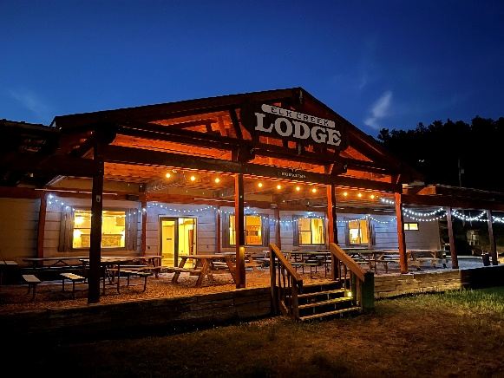

If you are looking for somewhere to relax & unwind, this is the place. Turkeys & deer wander through the grounds in the mornings & evenings.

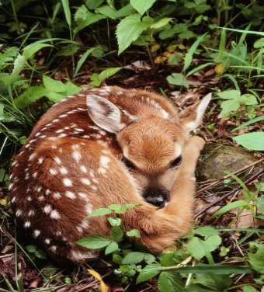

ELK CREEK RESORT
Spring and Summer Rates 2026
05/01 -09/30/26
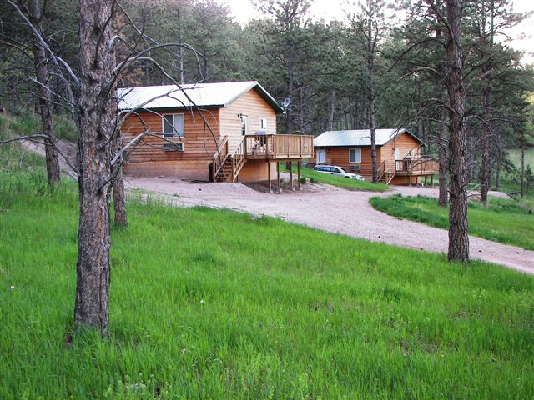

8220 Elk Creek Road

Piedmont, SD 57769

www.elkcreekresort.net

Email: info@elkcreekresort.net

605-787-4884

3 & 4-PLEX COTTAGE UNITS
Beautiful view overlooking the resort. Each room has a full bath & is furnished with a TV, A/C, heater, small refrigerator, phone, microwave, coffee pot & an entry porch. The kitchen rooms also include a range, refrigerator, sink, kitchen utensils, toaster & a dining table. There will be a $7.00 fee per person over the stated capacity. A $25.00 per pet fee will be applied to pet friendly rooms. Rates will vary based on reservation dates. (not valid during the Sturgis Rally)
Standard Room | Sleeps 4 People | $ 180.00-  $218.00
Standard Room w/kitchenette | Sleeps 5 People | $218.00  $254.00
Deluxe Room w/kitchenette | Sleeps 8 People | $273.00  $309.00

VACATION HOME
BI-LEVEL UNIT
Two levels ------  Each level has: | Two bedrooms with queen beds & large closets, full bathroom, living room, large kitchen, breakfast nook, plush futons, covered patio or open deck, air conditioning /heating unit. Sleeps 8 |  | $398.00 per level $435.00
 | LOG CABINS  Two bedrooms, 1 w/ queen, 1 w/ full bed; bath w/ shower; living room/kitchen; A/C-heater; & deck. Sleeps 6 |  | $362.00  $399.00
FURNISHED SLEEPING CABINS |  | Each cabin has an entry porch. One queen bed, 2 double sleepers w/ twins overhead. Includes A/C-heater, sm. refrigerator, table, chairs, all bedding (no towels), & picnic table. Guests use nearby shower house and restroom. Sleeps 8 |  | $145  $181

RVs / Camping
$5.00 more for holiday weekends

Electric (30/50 amp), Water, Sewer. | $ 65 and up
Electric (30/50 amp), Water | $ 57 and up
Electric (30/50 amp) | $ 54 and up
No Hook-ups | $ 41.00
Tents allowed anywhere except on RV sites (fee for tenting is for one person, add $5.00 for each extra person) add electric $5.00 | $29.00
RV pricing is based on 2 people. Each additional guest in a RV is $7.00 per person. Children 3 and under are free. These rates are not valid during the Sturgis Rally.

5.7 Sales tax will be added to all prices.
CANCELLATION POLICY: Cancellation must be made 72 hours in advance. Group event cancellations are explained in the Lodge folder.
*ACTIVITIES: Heated outdoor swimming pool, hiking, horseshoes, playground.
CONVENIENCE STORE: Snacks, drinks, groceries, camping supplies, & gifts.

ELK CREEK LODGE
Our lodge is the perfect facility for your family reunion, business retreat, wedding reception, party or banquet. Rental includes: use of tables and chairs, game room, patio and clean up. Rental rates vary depending on group size, function type and duration, and time of year. Reservations and a deposit are required. A list of caterers also available upon request.. (See Lodge brochure for pricing.)
PETRIFIED FOREST: (located on our property) 20-minute video, museum and a self-guided tour. Adults (13-60) $12.00, Seniors (60 & up) $10.00, & Children (4-12) $8.00 Plus tax. Children 3 yrs. and under are free.
Located at Petrified Forest:
Gallery of Stone Rock Shop - Specializing in Black Hills of South Dakota Petrified Wood
Pine Tree Gift Shop
Unique gifts, novelties, jewelry, & books.

Prices in effect from May 1st- Sept. 30th 2026